**PUJA STATIONARY PVT LTD**

**REPORTS**

**STOCK SUMMARY REPORT (AS ON 1-4-2017)**

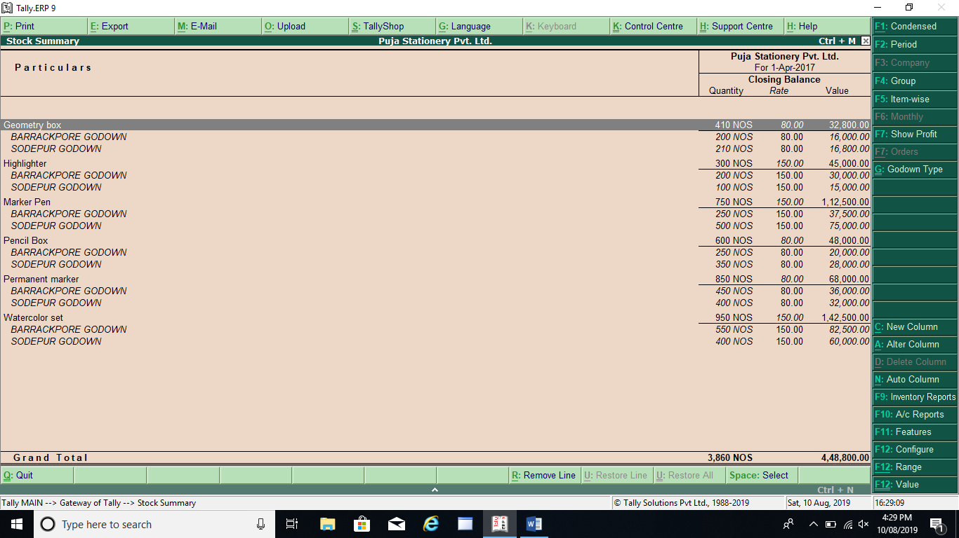

**STOCK SUMMARY REPORT (AS ON 31-5-2017)**

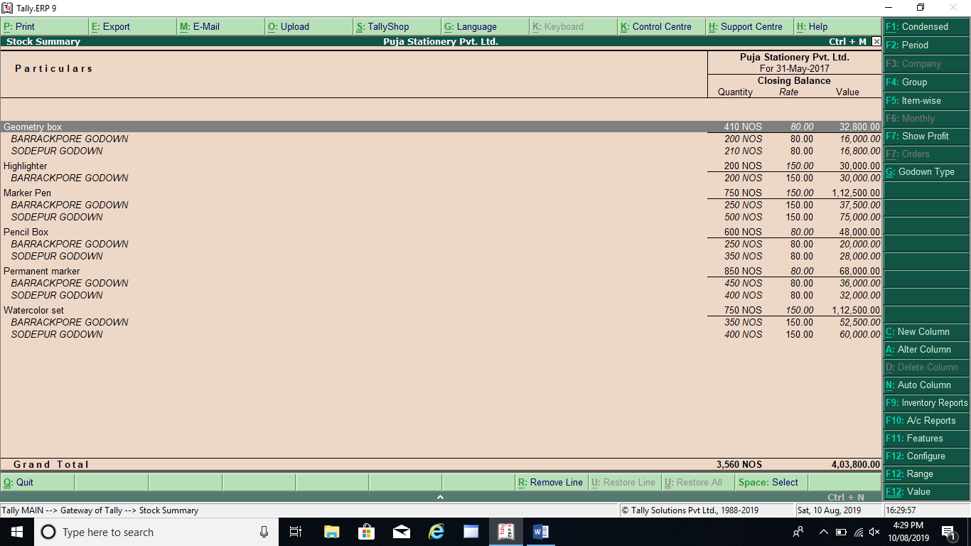

**TRIAL BALANCE REPORT (AS ON 1-4-2017)**

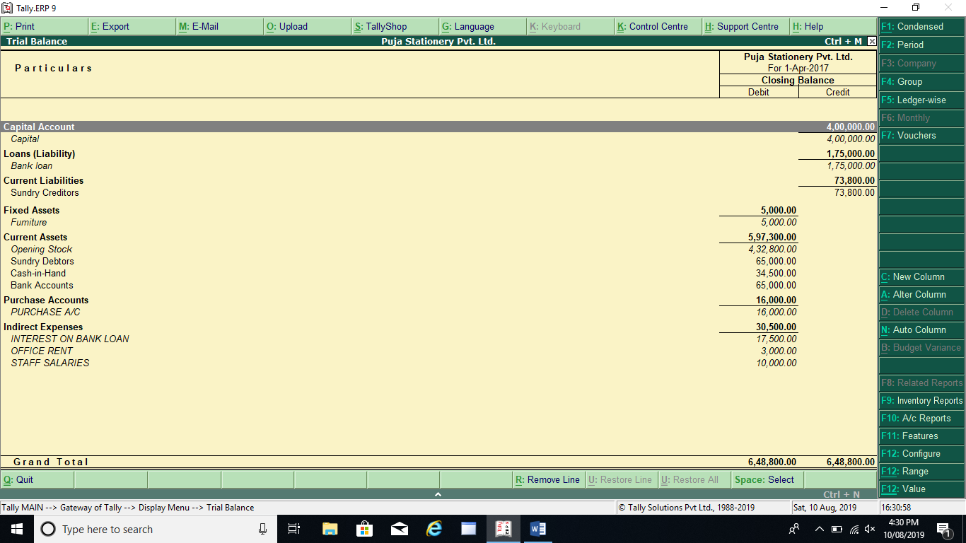

**TRIAL BALANCE REPORT (AS ON 31-5-2017)**

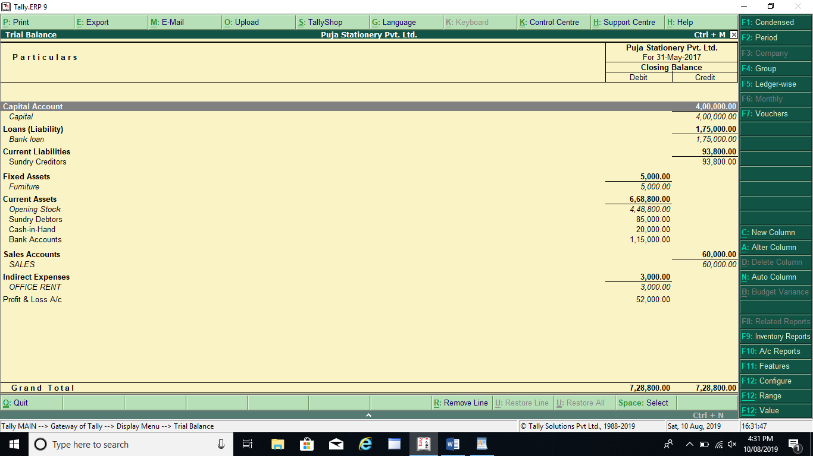

**DAYBOOK REPORT (FROM 1-4-2017 TO 31-5-2017)**

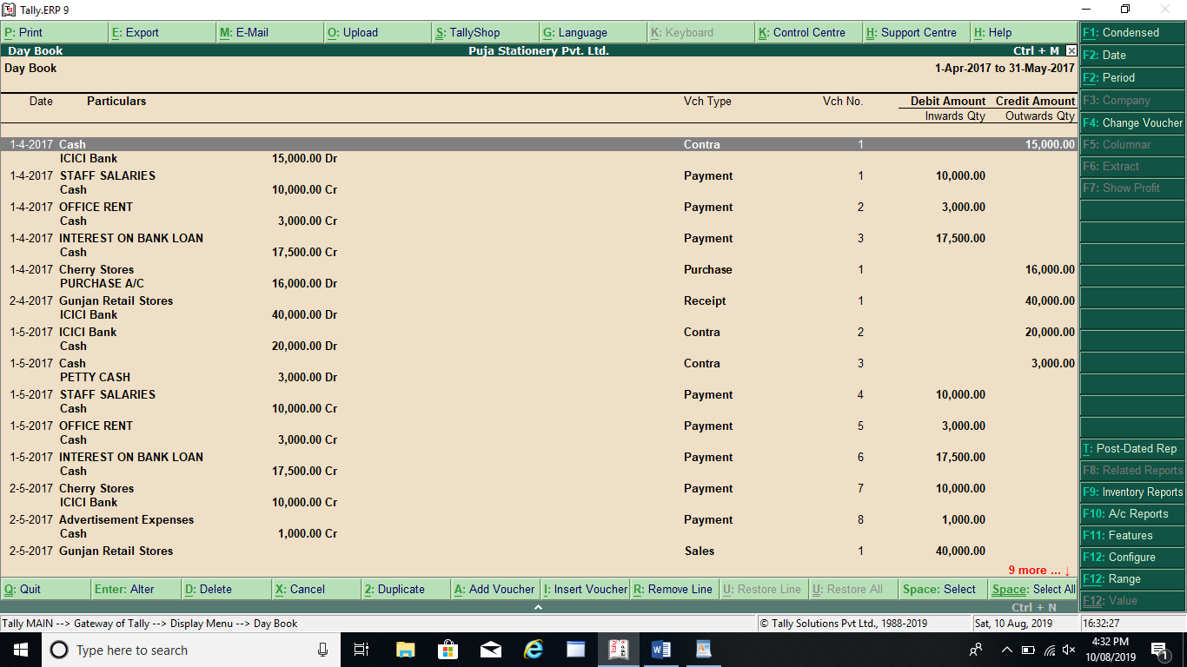

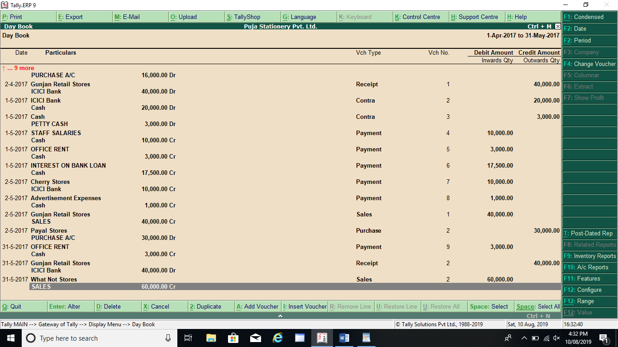

**PROFIT AND LOSS REPORT (AS ON 31-5-2017)**

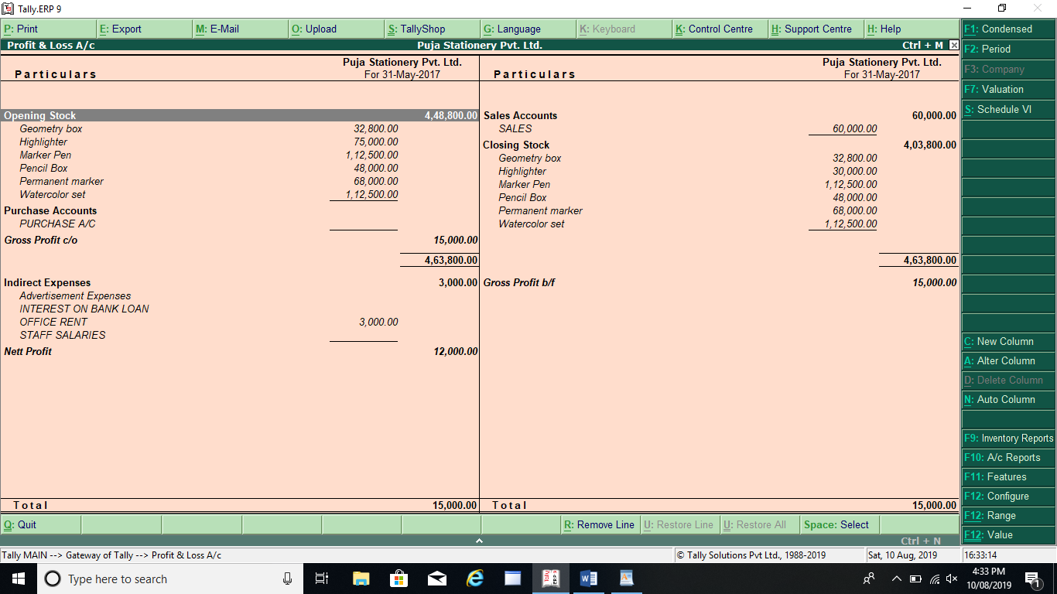

**BALANCE SHEET (AS ON 31-5-2017)**

